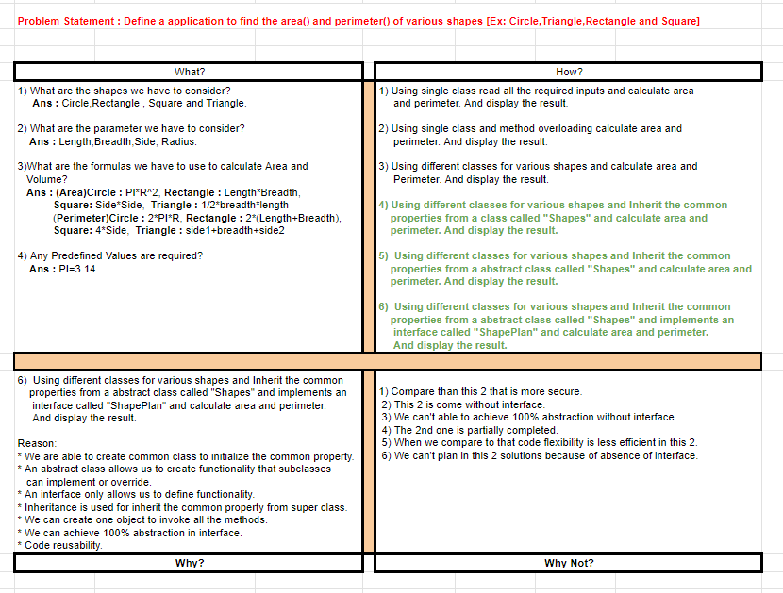

**Define a application to find the area() and perimeter() of various shapes [Ex: Circle,Triangle,Rectangle and Square]**

**Algorithm:**

**Step 1:** Start

**Step 2:** Define an interface ShapePlan with abstract methods area() and perimeter().

**Step 3:** Create an abstract class Shape that implements the ShapePlan interface.

**Step 4:** In abstract class create a method for initialization of values and display results.

**Step 5:** Create a concrete class for Circle, Rectangle, square and triangle that inherit from the abstract class.

**Step 6:** They implement their own area() and perimeter() methods specific to each shape.

**Step 7:** Then in the main class by using creation of objects we are able to display the results by calling display() method from abstract class.

**Program:**

**package com.dharshu.day25;**

**interface ShapePlan{**

**void display();**

**void area();**

**void perimeter();**

**}**

**abstract class Shape implements ShapePlan{**

**public void display() {**

**System.*out*.println("\n");**

**}**

**public abstract void area();**

**public abstract void perimeter();**

**}**

**class Square extends Shape{**

**int side;**

**Square(int side){**

**this.side=side;**

**}**

**public void area() {**

**System.*out*.println("Area of square : "+(side*side));**

**}**

**public void perimeter() {**

**System.*out*.println("Perimeter of Square : "+(4*side));**

**}**

**}**

**class Rectangle extends Shape{**

**int length,breadth;**

**Rectangle(int length,int breadth){**

**this.breadth=breadth;**

**this.length=length;**

**}**

**public void area() {**

**System.*out*.println("Area of Rectangle : "+(length*breadth));**

**}**

**public void perimeter() {**

**System.*out*.println("Perimeter of Rectangle : "+(2*(length*breadth)));**

**}**

**}**

**class Triangle extends Shape{**

**float length1,length2,height;**

**Triangle(float length1,float length2,float height){**

**this.length1=length1;**

**this.length2=length2;**

**this.height=height;**

**}**

**public void area() {**

**System.*out*.println("Area of Triangle : "+(0.5*length1*height));**

**}**

**public void perimeter() {**

**System.*out*.println("Perimeter of Triangle : "+(length1+length2+height));**

**}**

**}**

**class Circle extends Shape{**

**float radius;**

**Circle(float radius){**

**this.radius=radius;**

**}**

**public void area() {**

**System.*out*.println("Area of Circle : "+(3.14*radius*radius));**

**}**

**public void perimeter() {**

**System.*out*.println("Perimeter of Circle : "+(2*3.14*radius));**

**}**

**}**

**public class DifferentShapes {**

**public static void main(String[] args) {**

**Square s=new Square(5);**

**s.area();**

**s.perimeter();**

**Rectangle r=new Rectangle(2,4);**

**r.area();**

**r.perimeter();**

**Triangle t=new Triangle(3.0f,3.0f,3.0f);**

**t.area();**

**t.perimeter();**

**Circle c=new Circle(5);**

**c.area();**

**c.perimeter();**

**}**

**}**

**Output:**

